# VISA MENA/SSA/CISSEE Weekly Run

Run below job from DI-BILLING

“Visa Platform SSA MENA CISSEE Weekly Deals”  
  
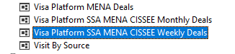

This will load the data in below three tables

SELECT * FROM rprt.VisitBySourcePlatformCISSEEDeals

SELECT * FROM rprt.VisitBySourcePlatformSSADeals

SELECT * FROM rprt.VisitBySourcePlatformMENADeals

Run below Alteryx workflow to pull data from above table and write into individual excel

[Gallery](http://10.204.210.202:1433/gallery/#!app/CISSEE-MENA-SSA-Weekly-Run/63ac3a07dd7f073208fb3bdf)  
  


**File Location**

\\clbnas01\OpsDataTeam\8. Team\Harshad\Ops Automation\Dev\Visa Automation\Visa MENA SSA CISSEE Deals

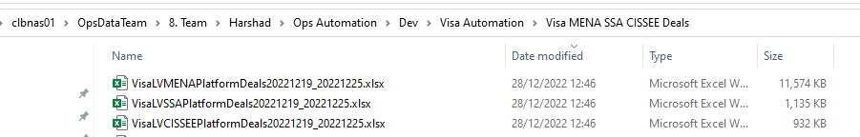

Share these files with Visa team on below location

P:\8F. OPS LOUNGEKEY\!!VISA LOUNGEKEY\!!Deal Types\!Visa CEMEA LoungeKey (Platform)\!Reporting\Ad hoc\MENA weekly reports

# VISA MENA/SSA/CISSEE Monthly Run

Run below job from DI-BILLING

“Visa Platform SSA MENA CISSEE Weekly Deals”  
  
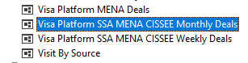

This will load the data in below three tables

SELECT * FROM rprt.VisitBySourcePlatformCISSEEDeals

SELECT * FROM rprt.VisitBySourcePlatformSSADeals

SELECT * FROM rprt.VisitBySourcePlatformMENADeals

Run below Alteryx workflow to pull data from above table and write into individual excel

[Analytics Gallery](http://10.204.210.202:1433/gallery/#!app/CISSEE-MENA-SSA-Monthly-Run/63ac462edd7f073208fb43e8)

**File Location**

\\clbnas01\OpsDataTeam\8. Team\Harshad\Ops Automation\Dev\Visa Automation\Visa MENA SSA CISSEE Deals



Share these files with Visa team on below location

P:\8F. OPS LOUNGEKEY\!!VISA LOUNGEKEY\!!Deal Types\!Visa CEMEA LoungeKey (Platform)\!Reporting\Ad hoc\MENA weekly reports